为降低文章返修的频次，请作者严格按照以下标准自检文章的版面
页面设置 | 页边距：上：3.1厘米，下：5.01厘米，左：2.54厘米，右：3.6厘米  纸张大小：Letter，宽度：21.59厘米，高度：27.94厘米  无网格
篇幅 | 全文单栏不低于8页。
作者 | 需要填写所有作者邮箱。第一作者的邮箱必须是有效的，以确保能够接收版权签署邮件；在文章第一页的左下角插入一则脚注，内容为“Corresponding author”，通讯作者的邮箱尽可能使用机构邮箱。
CCS | 根据ACM的出版要求，请在正文中关键词的下面补充CCS CONCEPTS部分。CCS操作如下：登录https://dl.acm.org/ccs，根据论文研究方向选择类目，复制所选类目并张贴+备注。粘贴+备注请参考第2页详细指引）。
Keywords | 至少3个关键词。
标题 | Paper Title (字号小四 ，加粗，左对齐)
 | 一级标题格式统一（大写，字号 小五，加粗）
 | 二级标题格式统一（字号 小五，加粗）
 | 三级标题格式统一（字号 小五，斜体，加粗，末尾添加句号）
图片 | 图：所有图片应为高清晰度（在100%阅读模式下，图中文本数据应能够清晰可读），且图片中不得包含中文字符。
 | 图：每张图片应仅对应一个标题。如果存在多张图片，请将这些图片整合为一张图片。
 | 图片标题：①所有“Figure”应使用全称，并在标题末尾添加句号。②所有图片必须在正文中引用，并按照阿拉伯数字的顺序排列（例如，Figure 1、Figure 2、Figure 3等）。
表格 | 表格：所有表格均需使用可编辑格式。如果表中包含公式，必须采用MathType或Word自带的编辑器进行创作。
 | 表格标题：①所有“Table”应使用全称，并在标题末尾添加句号。②所有表格必须在正文中进行引用，并按照阿拉伯数字的顺序排列（例如，Table 1、Table 2、Table 3等）。
公式 | 所有公式必须使用MathType或Word自带的编辑器进行创建，其他工具所创建的公式将被视为无效。
 | 所有公式应以可编辑格式呈现，并按阿拉伯数字顺序排序（例如：(1)、(2)、(3)等）。
 | 公式的序号需标注在公式外部，切勿将其嵌入公式编辑器内部。
文献 | 所引用的文献必须注明年份并且是最新的，数量不得少于五条。同时，被引用文献的作者应来自三个或三个以上的国家。参考文献在正文中的引用需采用“[阿拉伯数字]”的上标形式进行标注。
 | 所有文献必须在正文中正确引用。
PS：为确保出版流程顺利进行，请投稿人务必收集好所有作者的ORCID，该信息将在后续签署出版协议时作为必要信息进行填写。如尚未注册可提前通过该链接进行注册：https://orcid.org/register。

* ACM的排版要求相对复杂，因此作者只需确保以上信息的准确性和完整性。文章在交付出版前，排版编辑将会根据出版物的要求进行格式调整。论文集交付出版前，编辑会通知作者进行校稿，以确认所有内容的正确性和排版的合规性。

一、CCS张贴操作指引：
- 访问CCS链接：https://dl.acm.org/ccs
- 根据文章的研究方向，选择符合文章内容的（三级）类目
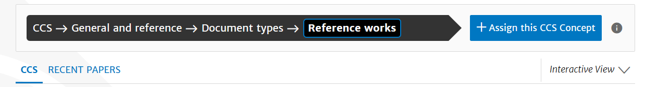
- 张贴CCS（复制网页所选择的关键词，切勿随意更改）。
示例：
CCS CONCEPTS: General and reference ~ Document types ~ Document types（示例仅供参考，切勿照抄照搬）
二、复制代码至DOCX文件的备注栏：
  - 选择类目

  - 添加CCS
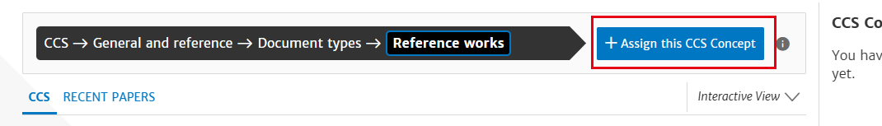
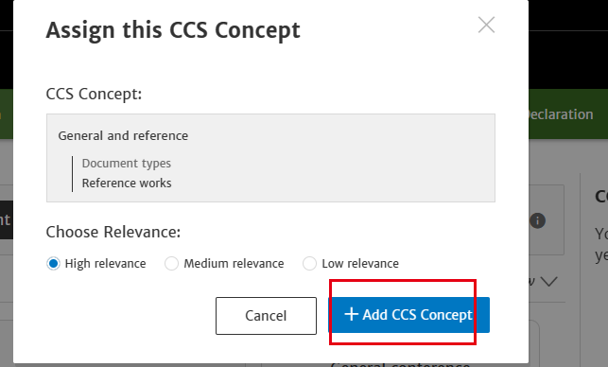

  - 创建代码
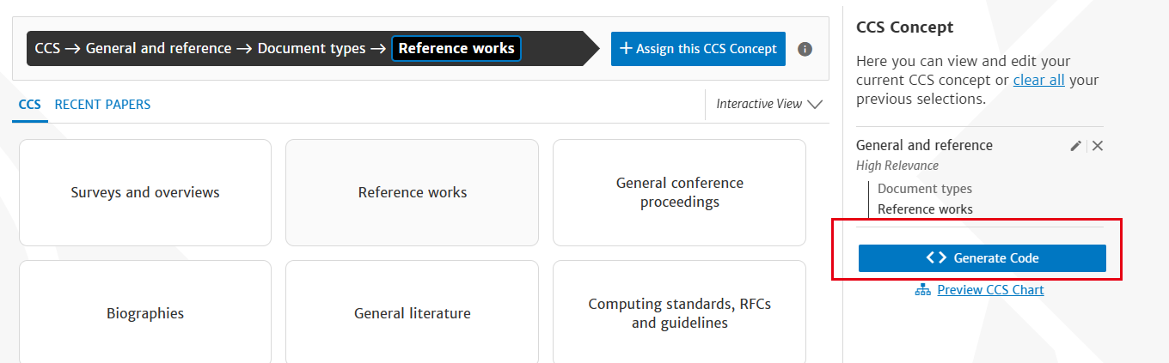
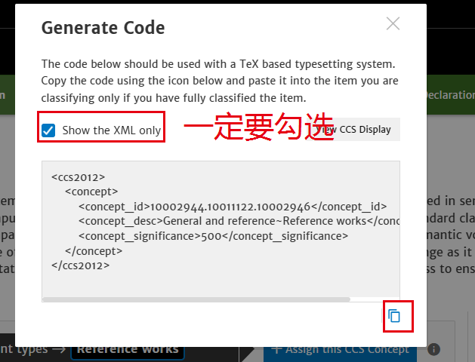
  - 复制代码至备注栏。^{备注路径：“文件”→“信息”→“备注”。}
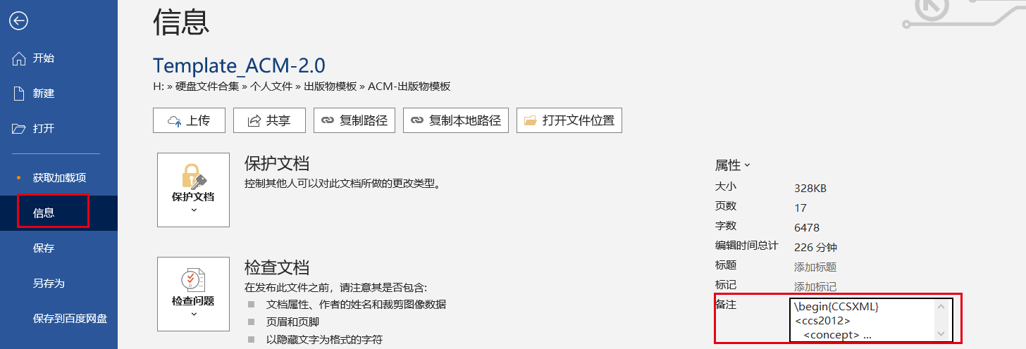

Submission Template for ACM Papers
First Author's Name
First author's affiliation, an Institution with a very long name, city, post number, Country, xxxx@gmail.com
Second Author's Name
Second author's affiliation, an Institution with a very long name, city, post number, Country, xvvx@gmail.com
Third Author's Name
Third author's affiliation, an Institution with a very long name, city, post number, Country, xaaaxx@edu.cn
Abstract
Although there is no distinctive header, this is the abstract. This submission template allows authors to submit their papers for review to an ACM Conference or Journal without any output design specifications incorporated at this point in the process. The ACM manuscript template is a single column document that allows authors to type their content into the pre-existing set of paragraph formatting styles applied to the sample placeholder text here. Throughout the document you will find further instructions on how to format your text. If your conference’s review process will be double-blind: The submitted document should not include author information and should not include acknowledgments, citations or discussion of related work that would make the authorship apparent. Submissions containing author identifying information may be subject to rejection without review. Upon acceptance, the author and affiliation information must be added to your paper.
CCS CONCEPTS
General and reference ~ Document types ~ Document types
Keywords
Keyword number 1, Keyword number 2, Keyword number 3, Keyword number 4
- Introduction
ACM's new manuscript submission template aims to provide consistent styles for use across ACM publications, and incorporates accessibility and metadata-extraction functionality necessary for future Digital Library endeavors. Numerous ACM and SIG-specific templates have been examined, and their unique features incorporated into this single new template. If you are new to publishing with ACM, this document is a valuable guide to the process of preparing your work for publication. If you have published with ACM before, this document provides insight and instruction into the current process for preparing` your manuscript.
  - Accessibility
Following the guidelines throughout this template will also improve the accessibility of your manuscript and increase the audience for your work. Ensure that heading styles are applied as instructed, tables are created using Word’s table feature (rather than an image), figures have a text equivalent, and list styles are applied as instructed.
    - More about the submission template. （一定要句号）
This submission version of your paper should not have headers or footers, these will be added when your manuscript is processed after acceptance. It should remain in a one-column format—please do not alter any of the styles or margins.
- Inserting Content Elements
The next subsections provide instructions on how to insert figures, tables, and equations in your document.
  - Tables
Tables are “float elements” which should be inserted after their first text reference and have specific styles for identification. Do not use images to present tables, or they will be inaccessible to readers using assistive technologies.
Table 1. Styles available in the Word template.
Style Tag | Definition | Style Tag | Definition
Title_document | main title of article | ListParagraph | list items
Subtitle | subtitle of article | Statements | math statements
Authors | author name | Extract | block quotations
Affiliation | author affiliation information | Algorithm Caption | caption for algorithm
AuthNotes | footnote to author(s) | AckHead | heading for acknowledgements
Abstract | abstract text | AckPara | acknowledgements text
CCSHead | heading for CSS Concepts | GrantSponsor | sponsor of grant
CCSDescription | CSS terms | GrantNumber | number for the grant
KeyWordHead | heading for keywords | ReferenceHead | heading for references
Keywords | keywords text | Bib_entry | references
ORCID | author's ORCHID # | AppendixH1 | appendix heading level 1
Head1 | heading level 1 | AppendixH2 | appendix heading level 2
Head2 | heading level 2 | AppendixH3 | appendix heading level 3
Head3 | heading level 3 | TableCaption | title of table
PostHeadPara | first paragraph after a heading | TableHead  TableFootnote | column head of table  footnote to table
Para | Subsequent paragraphs of general text | Image | figures
ParaContinue  DisplayFormula | flush left text after display items like math equations, lists etc.  numbered math equation | DOI | Digital object identifier
DisplayFormulaUnnum | unnumbered equations | Label | labelª
ComputerCode | Display Computer codes | In-text code | intext computer code
Short Title | Short title of article
  - Figures
Figures are “float elements” which should be inserted after their first text reference, and have specific styles for identification. Insert a figure and apply the “Image” paragraph style to it. For the figure caption, apply the style “FigureCaption.”
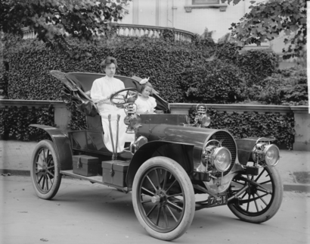
Figure 1. 1907 Franklin Model D roadster. Photograph by Harris & Ewing, Inc. [Public domain], via Wikimedia Commons. (https://goo.gl/VLCRBB)

Figure 3. The layout of multipart images should be as per the above example within the table. All images must have the “Image” style applied.
  - Equations
There are two types of math equations: the numbered display math equation and the un-numbered display math equation. Below are examples of both.
    - DisplayFormula.
The DisplayFormula style is applied in the numbered math equation. A numbered display equation always has an equation number (label) on the right.
$\frac{x=-b±\sqrt{b^{2}-4ac}}{2a}$ (1)
  - Algorithms（算法不要放在表格中）
Algorithms use the styles “AlgorithmCaption” and “Algorithm”.
ALGORITHM 1: Iterative Algorithm
current_position center
current_direction up
current_position is inside circle
while current_position is inside circle, do
neighborhood all grid hexes within two hexes from current_position
for each hex in neighborhood, do
for each neuron in hex do
convert neuron_orientation to vector
scale vector by neuron_excitation
vector_sum vector_sum + vector
end
end
normalize vector_sum
end
- conclusion
Acknowledgments are placed before the references. Add information about grants, awards, or other types of funding that you have received to support your research. Author can capture the grant sponsor information, by selecting the grant sponsor text and apply style ‘GrantSponsor’. After this, select grant no and apply ‘GrantNumber’ from style panel. Example of Grant sponsor: Competitive Research Programme and example of Grant no: CRP 10-2012-03.
ACKNOWLEDGMENTS
Acknowledgments are placed before the references. Add information about grants, awards, or other types of funding that you have received to support your research. Author can capture the grant sponsor information, by selecting the grant sponsor text and apply style ‘GrantSponsor’. After this, select grant no and apply ‘GrantNumber’ from style panel. Example of Grant sponsor: Competitive Research Programme and example of Grant no: CRP 10-2012-03.
REFERENCES（一定要有出版年份）
- Atul Adya, Paramvir Bahl, Jitendra Padhye, Alec Wolman, and Lidong Zhou. 2004. A multi-radio unification protocol for IEEE 802.11 wireless networks. In Proceedings of the IEEE 1st International Conference on Broadnets Networks (BroadNets’04) IEEE, Los Alamitos, CA, 210–217. https://doi.org/10.1109/BROADNETS.2004.8.
- Sam Anzaroot and Andrew McCallum. 2013. UMass Citation Field Extraction Dataset. Retrieved May 27, 2019 from http://www.iesl.cs.umass.edu/data/data-umasscitationfield.
- Martin A. Fischler and Robert C. Bolles. 1981. Random sample consensus: a paradigm for model fitting with applications to image analysis and automated cartography. Commun. ACM 24, 6 (June 1981), 381–395.

Corresponding author.

